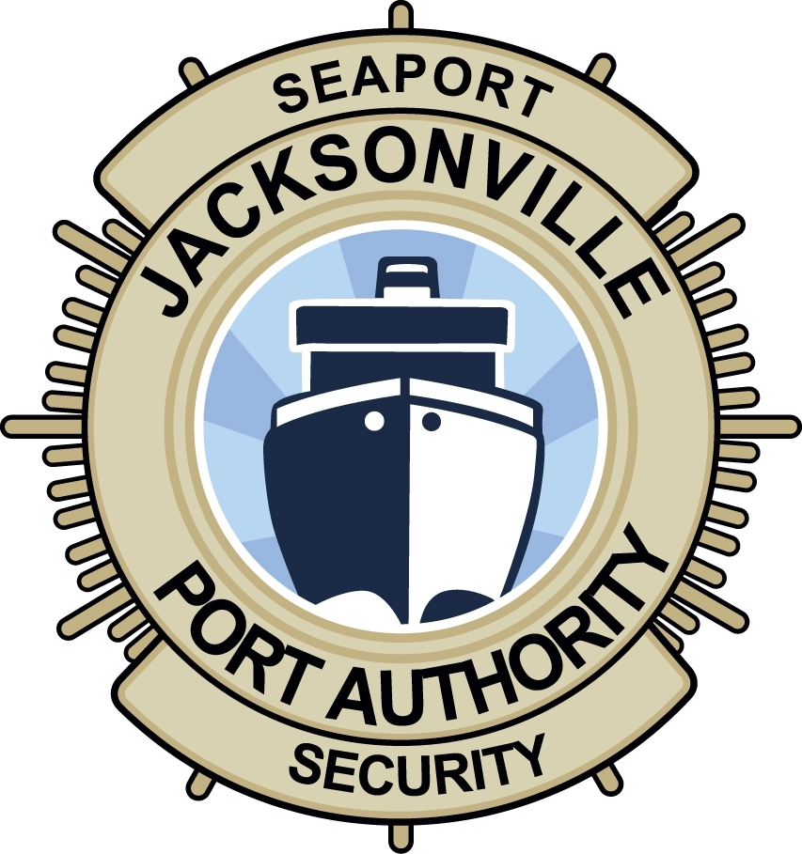 JAXPORT Access Termination Notice

Submit this notice to The JAXPORT Access Control Center within 24 hours of termination of an Employee or Vendor who will no longer require access to JAXPORT.

Your Company Name: _______________________________________ Date: __________________
Please Print

Authorized Agent: ____________________________ Signature: _______________________________
Please Print

Your Phone#: ___________________ Title: __________________________________________

Please check the box that applies:

Employee Termination Vendor Termination Contractor Termination Temp. Agency Worker Termination

Please check the location(s) where the individual or business operated:

Talleyrand (TMT) Blount Island (BI) JAXPORT Cruise Terminal (CT) JAXPORT Headquarters (PCOB)

Full Name, Date of Birth, of the individual who no longer requires port access:

Name: __________________________________________ DOB: __________________

Date of termination: _________________________

Did you collect the JAXPORT Badge? YES NO

Was a criminal violation or security violation involved? YES NO

If so, was a report filed? YES NO

If yes, please write the report/ CCR number: ________________________________

Please note the following: Per the Code of Federal Regulations 49 CFR 1572.19(c), the TWIC® is the property of the Transportation Security Administration (TSA), and held by the individual to whom the card was issued.
The TWIC may not be confiscated from a terminated employee (JAXPORT Access Control will NOT accept the TWIC of a terminated employee).

Upon completing this form, please save and send as an attachment to accesscontrol@jaxport.com

You may also deliver a printed and signed copy in person to the JAXPORT Access Control Center,
Located at: 9620 Dave Rawls Blvd. 1st Floor, Jacksonville, FL 32226
Hours of Operation: Monday through Friday, 7:30 a.m. – 4:30 p.m. Phone#: (904) 357-3344

